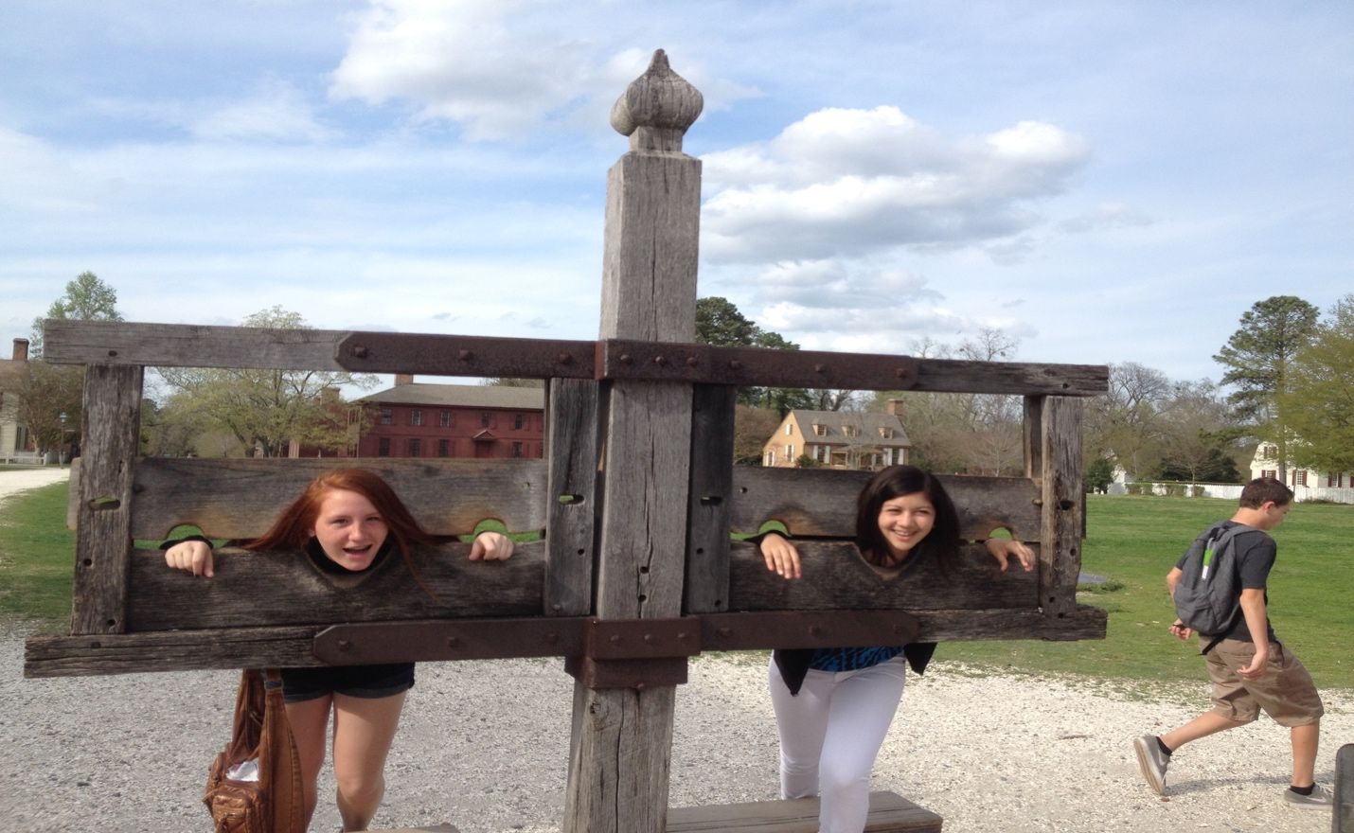
Freedom Middle School Itinerary
Williamsburg / Washington D.C. / New York City

Day 1 Saturday April 8, 2017

1:00 PM Motor coach meets with group at Freedom for airport transfer
9:00 PM Depart Long Beach Airport on Jet Blue Flight #14
5:16 AM Arrive at JFK Airport in NYC for connecting flight at 5:16 AM

Day 2 Sunday April 9, 2017
8:00 AM -Depart JFK Airport on Jet Blue Flight #1307 at 8:00 AM
($20 stipend)
9:30 AM -Arrive at Dulles Airport in DC and meet with escort and bus
Depart the airport for Williamsburg, Virginia-Lunch ($15 stipend)
Colonial Williamsburg Tour
Check into the Comforts Suits Bypass, Williamsburg, Virginia
Dinner at Sal’s Ristorante Italiano
Day 3 Monday April 10, 2017
Buffet Breakfast at the hotel
Yorktown victory center
Jamestown settlement with lunch ($15 stipend to be provided)
Governor’s Palace
Return to hotel
Dinner at King’s Arm Tavern
Night Time Ghost Tour of Colonial Williamsburg
Day 4 Tuesday April 11, 2017
Buffet Breakfast at the hotel and check out
Monticello – Thomas Jefferson’s Mansion and Slave Plantation
Colonial Lunch at Michie’s Tavern
Depart for Washington D.C
Colonial Dinner at Hill Country BBQ
Lincoln Memorial, Vietnam Memorial
Korean War Veterans Memorial
Check into the Arlington Court Suites, Arlington Virginia
Day 5 Wednesday April 12, 2017
Buffet Breakfast at hotel
White House Appointment
Iwo Jima Memorial
Lunch at National Place
US Capital Tour Appointment at 12:30 PM
Ford’s Theater Appointment at 2:30
Arlington National Cemetery
National Archives
Dinner at Carmines
FDR Memorial, Martin Luther King Jr. memorial, World War II Memorial, White House

Day 6 Thursday April 13, 2017
Breakfast at hotel and check out
Jefferson Memorial
National Museum of African American
History & Culture
Museum of American History, Museum of Natural History
National Air & Space Museum ($20 stipend for lunch)
Depart for New York City with dinner in route ($15.00 dinner)
Top of Rock-Observation Deck
Check into the Wyndham Garden, Long Island City, NYC

Day 7 Friday April 14, 2017
Breakfast at Court Square Diner (45-30 23rdST, Long Island City)
Guided Tour of New York City/Central Park
Lunch at Hard Rock Café
9/11 Museum (Reservations)
9/11 Memorial
Dinner at Havana Central, Times Square
Broadway Show: KinkY Boots

Day 8 Saturday April 15, 2017
Check out of the hotel
Breakfast at Court Square Diner
Staten Island Ferry Ride to view
Statue of Liberty in New York Harbor
Grand Central Terminal and 5th Avenue with lunch ($15.00 stipend)

5:00 PM Depart for JFK Airport ($15 stipend)
9:20 PM Depart JFK on Jet Blue Flight #1323

Day 9 Sunday April 16, 2017 12:51 AM
Easter Sunday
Arrive at Los Angeles Airport and meet motor coach for transfer to Freedom

